ASSESSMENT - 11 | PYTHON - 04

*“SET FUNCTIONS, PYTHON FUNCTION, DOCSTRING”*



Submitted By

VAIBHAV PATIDAR

IPS ACADEMY, INDORE (M.P.)

**Date :** 15-12-2023

**Week 2** | **Day - 05**

**SETS IN PYTHON :**

* Set in Python is a collection of unique elements which are unordered and mutable.
* Python provides various functions to work with Set :
  + add(): Adds a given element to a set
  + clear(): Removes all elements from the set
  + discard(): Removes the element from the set
  + pop(): Returns and removes a random element from the set
  + remove(): Removes the element from the set

**Writing a program to create set, and using ADD(), CLEAR(), DISCARD(), POP() & REMOVE() functions on it :**

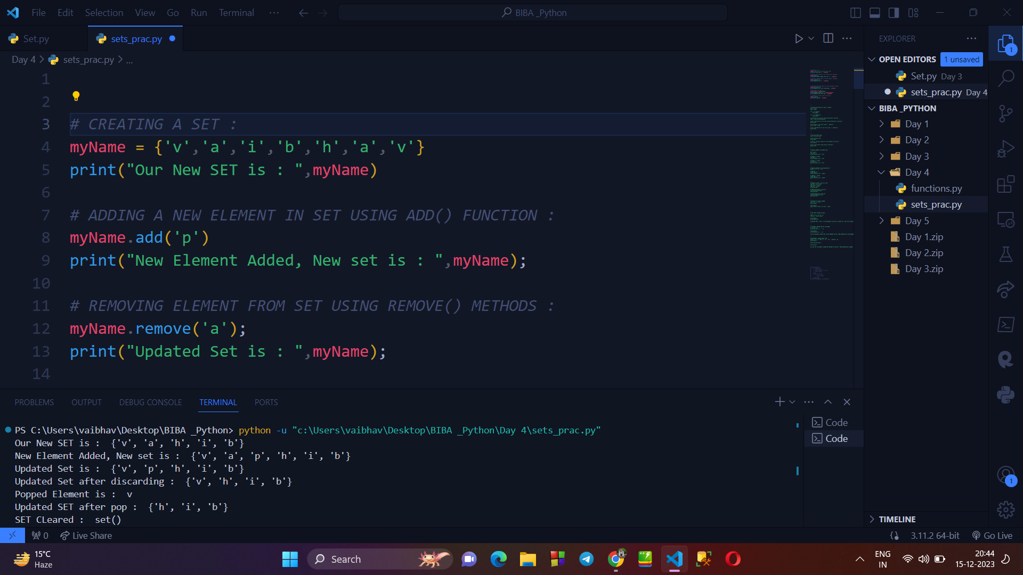

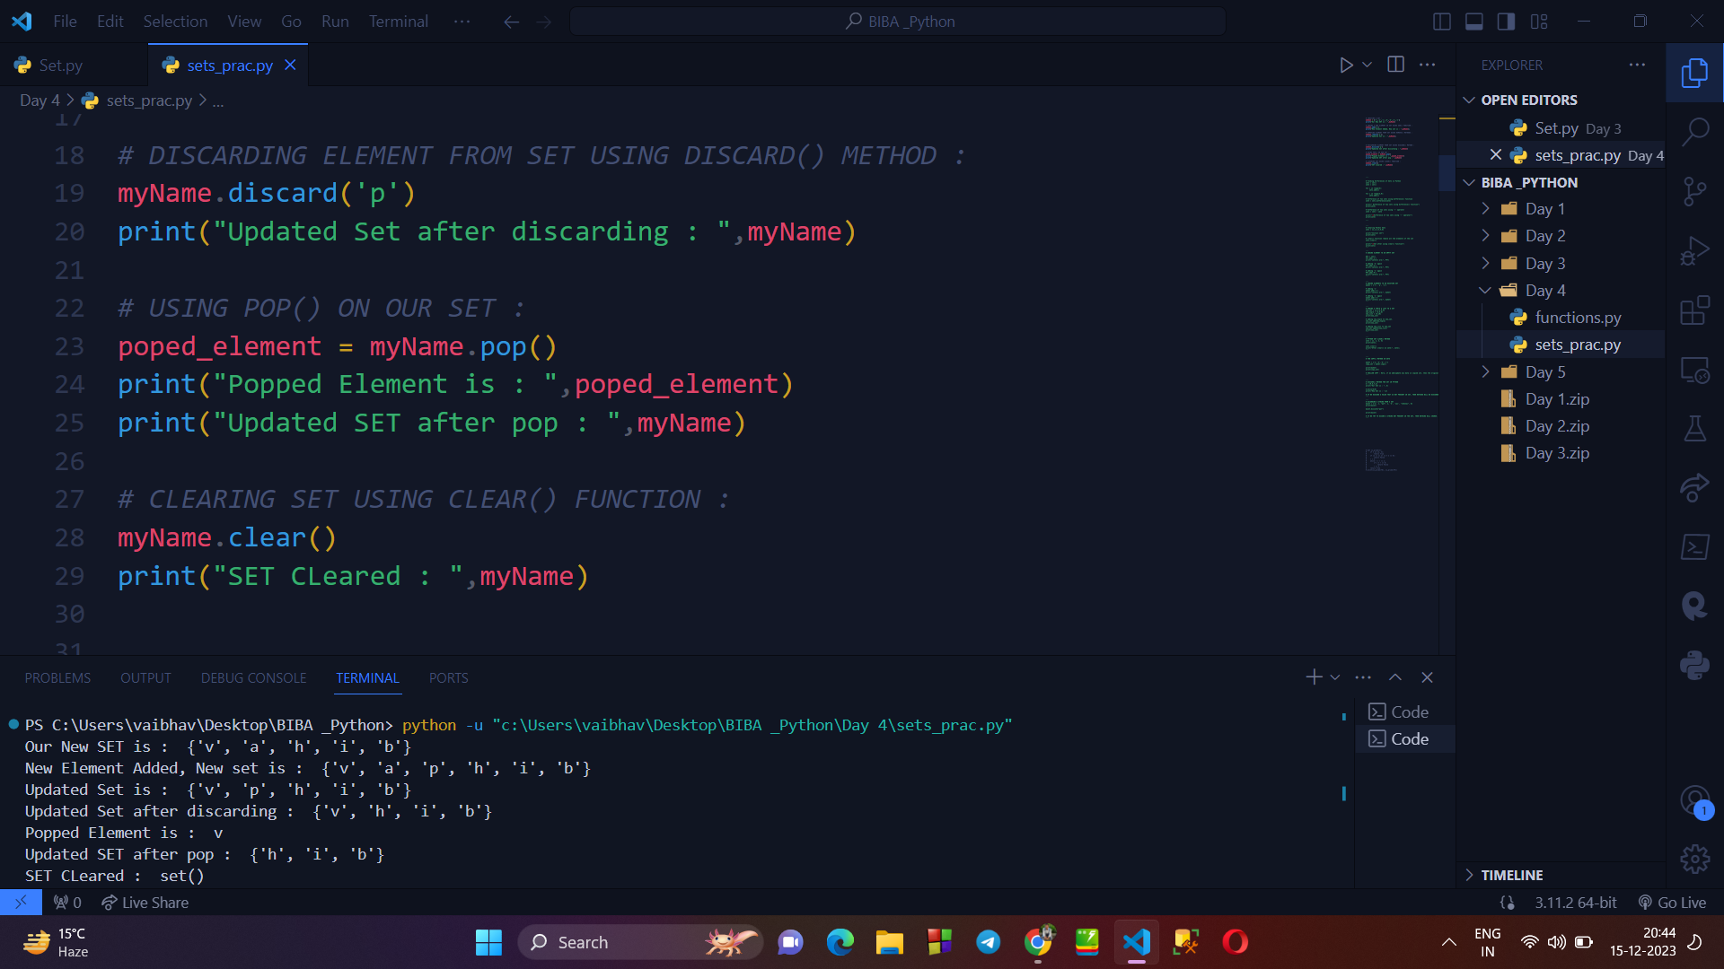

**→ Types of SET Function :**

* add() : Adds a given element to a set
* clear() : Removes all elements from the set.
* copy() : Returns a shallow copy of the set
* difference() : Returns a set that is the difference between two sets.
* difference_update() : Updates the existing caller set with the difference between two sets
* discard() : Removes the element from the set.
* frozenset() : Return an immutable frozenset object
* intersection() : Returns a set that has the intersection of all sets
* intersection_update() : Updates the existing caller set with the intersection of sets
* isdisjoint() : Checks whether the sets are disjoint or not
* issubset() : Returns True if all elements of a set A are present in another set B
* issuperset() : Returns True if all elements of a set A occupies set B
* pop(): Returns and removes a random element from the set
* remove() : Removes the element from the set
* symmetric_difference(): Returns a set which is the symmetric difference between the two sets
* symmetric_difference_update() : Updates the existing caller set with the symmetric difference of sets
* union():Returns a set that has the union of all sets
* update(): Adds elements to the set.

**→ FROZEN SETS :**

* A frozenset is a immutable set that cannot be modified once it is created.

**Writing program to show UNON, INTERSECTION, DIFFERENCE, ISSUBSET between 2 frozen sets :**

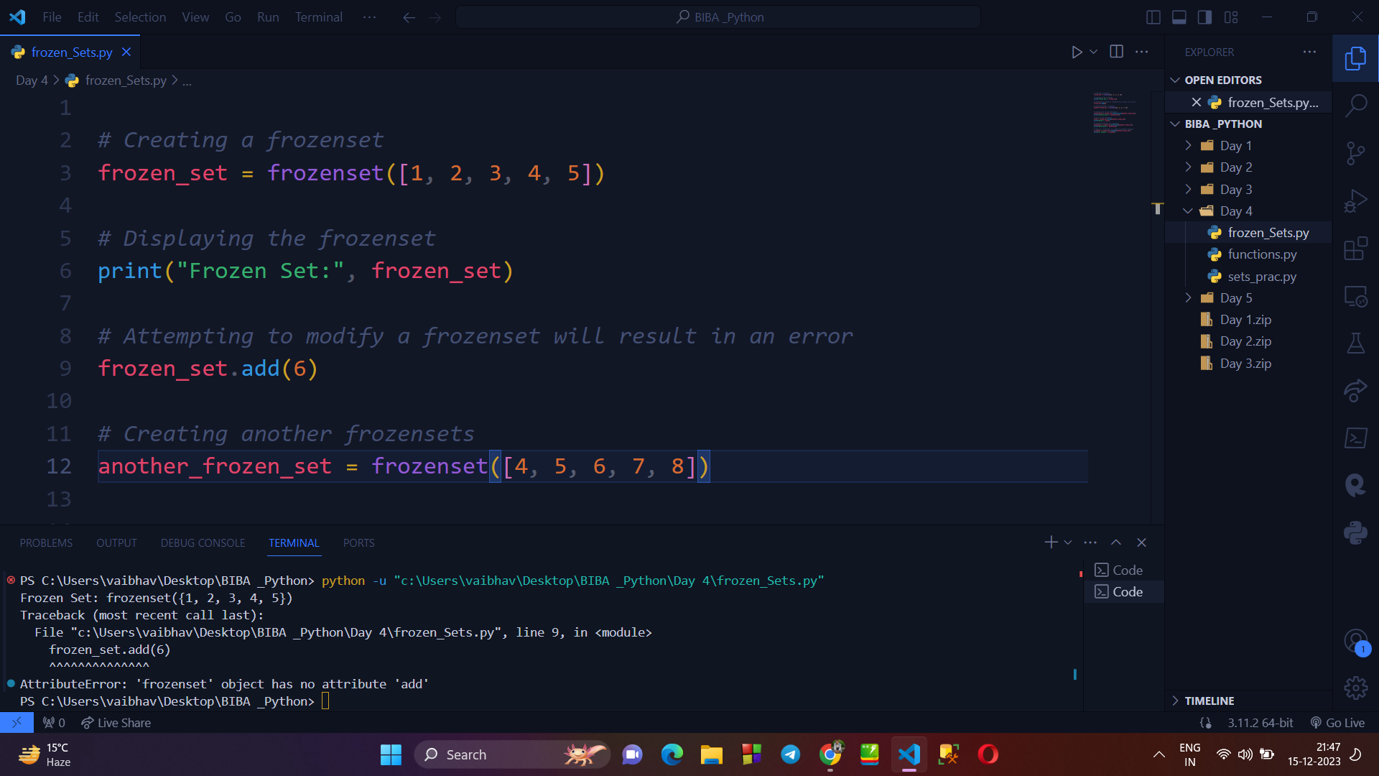

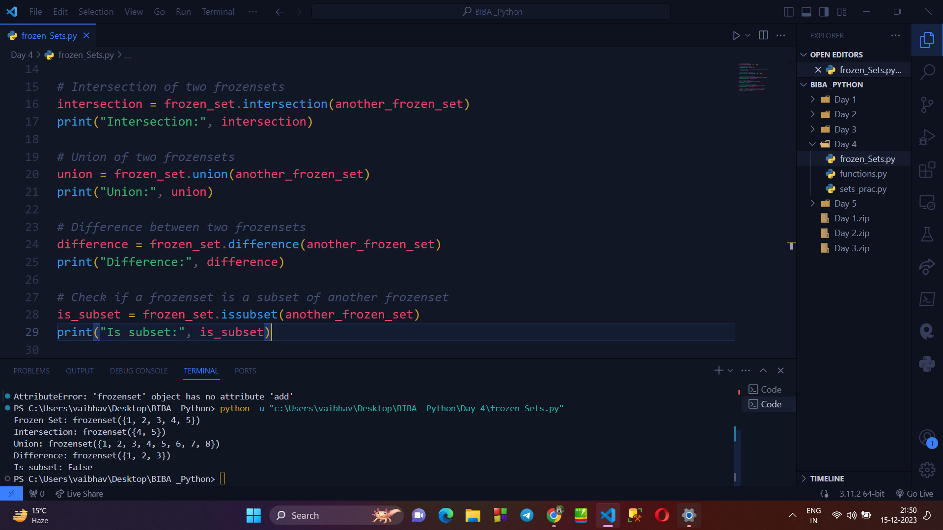

**→ UNION, INTERSECTION, DIFFERENCE, CLEAR FUNCTION IN SET :**

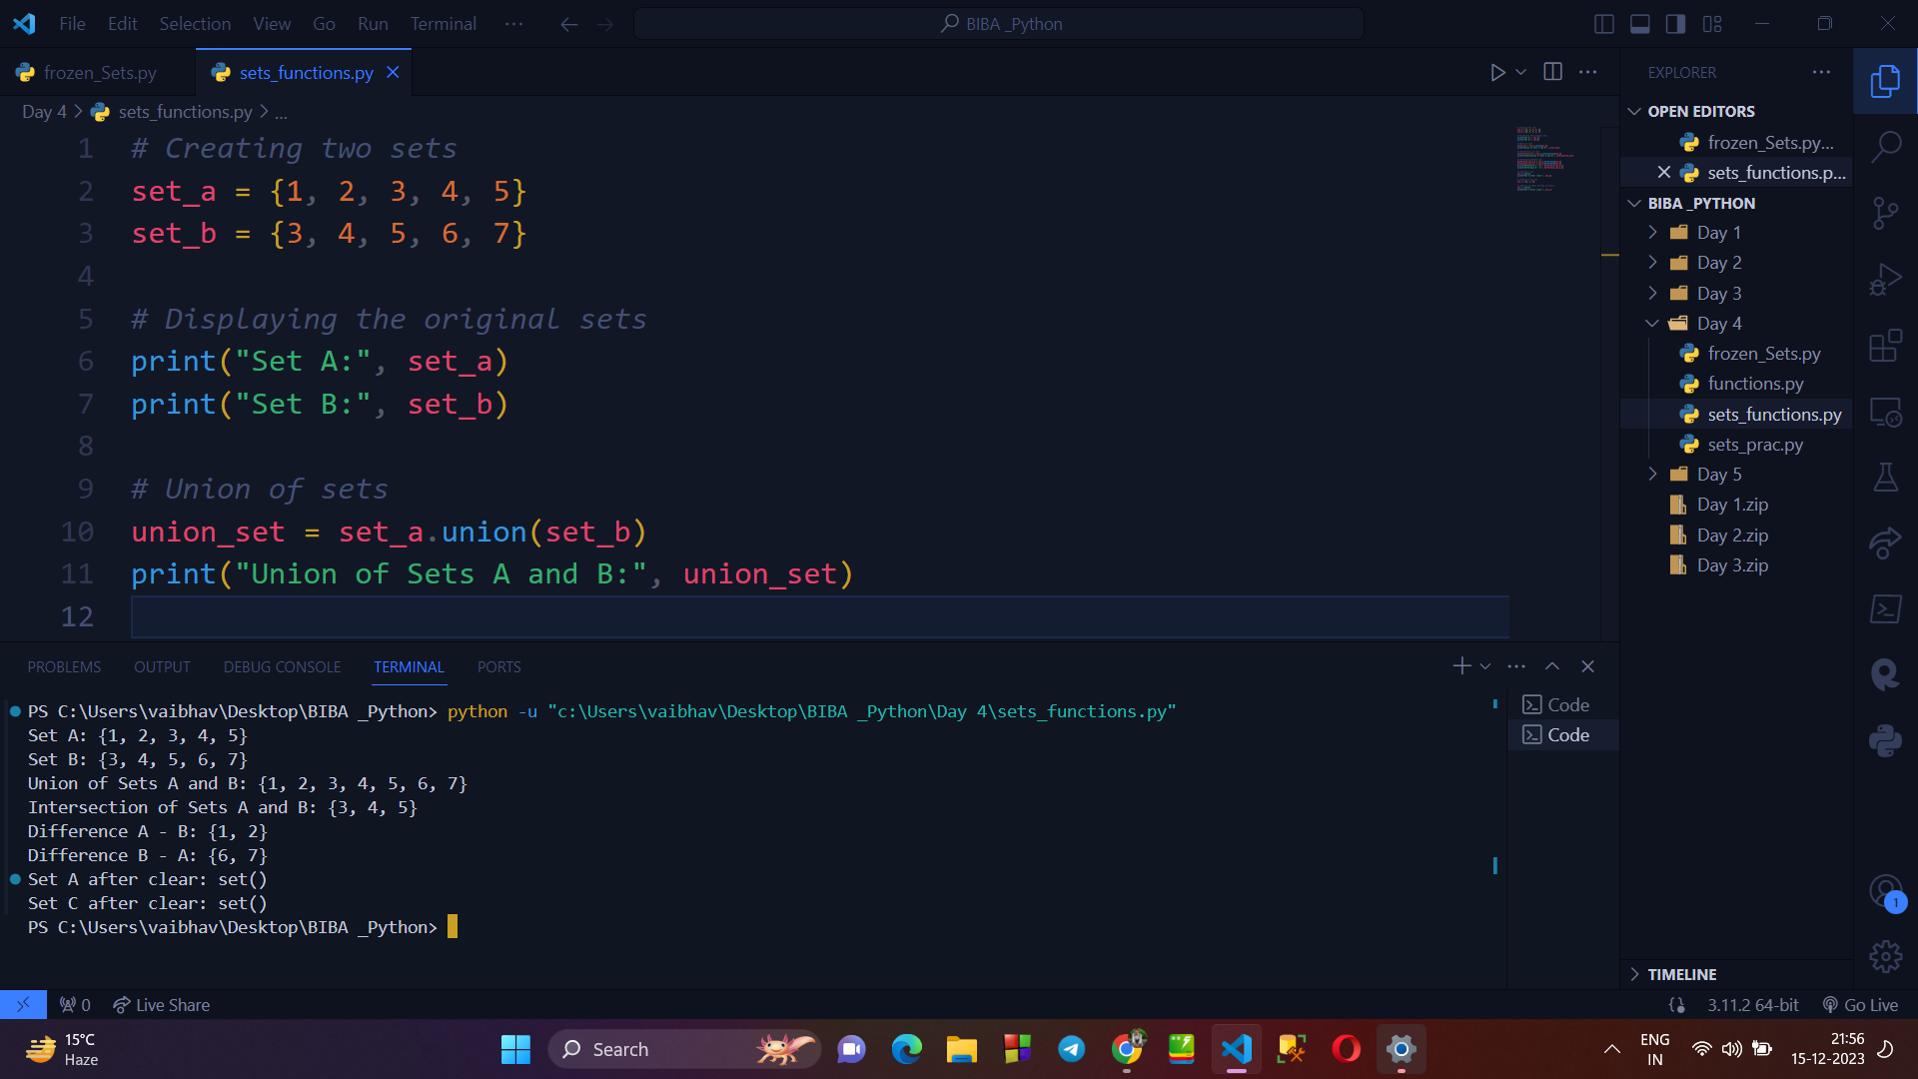

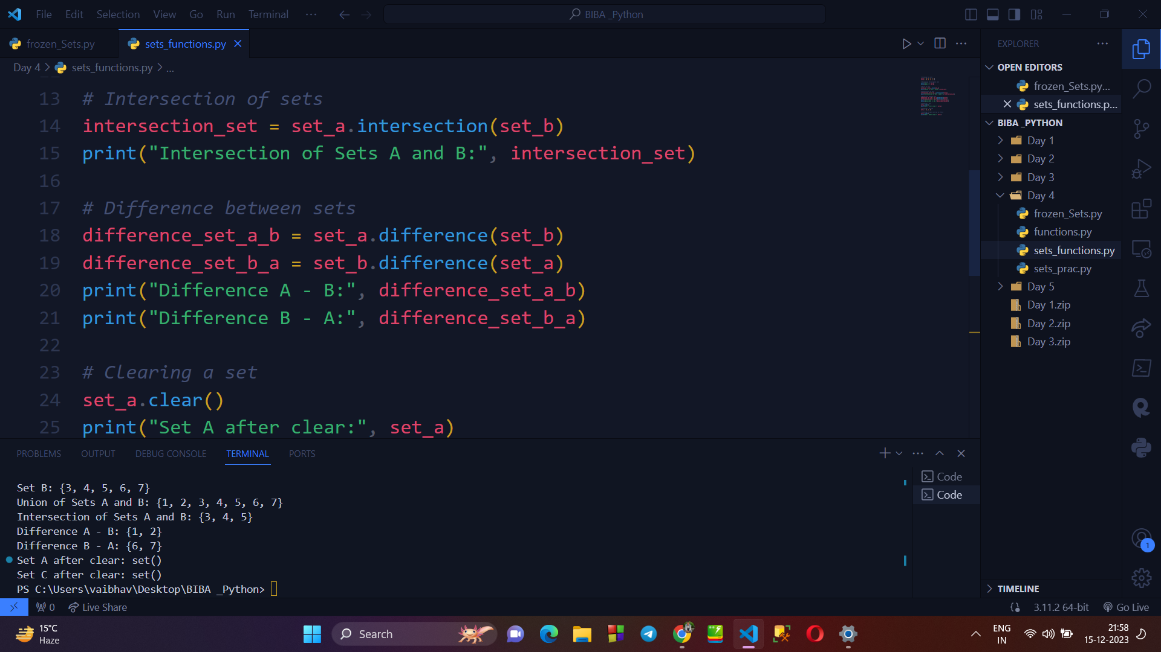

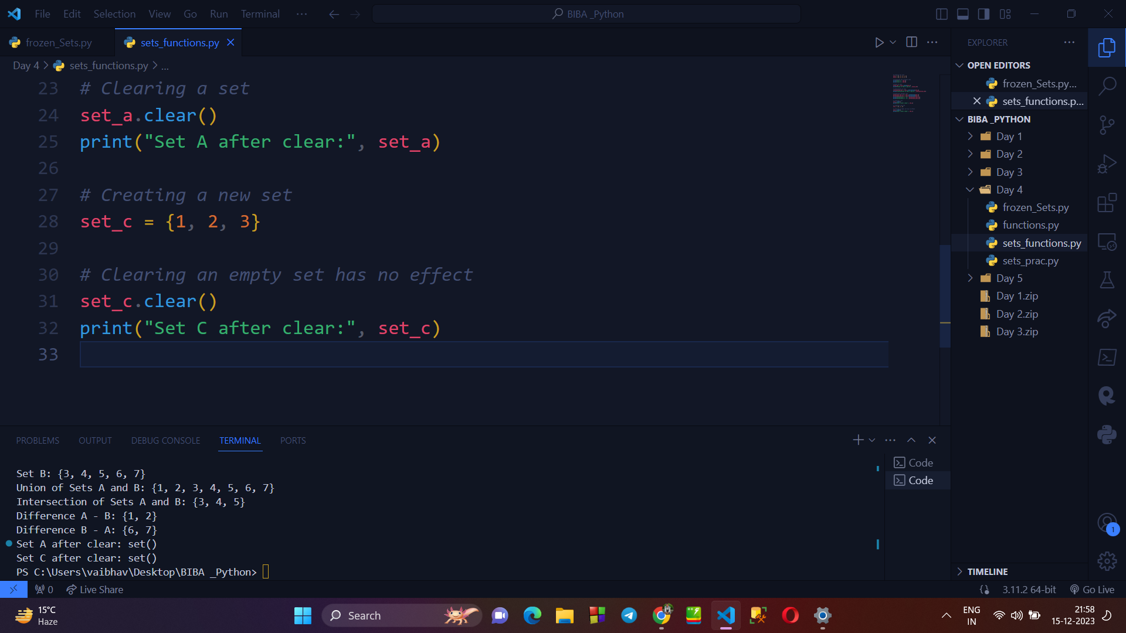

→ **FUNCTIONS IN PYTHON**

* Function are generally used to reuse the code again n again wherever required.
* There are mainly 2 types of functions in python : built-in & user-defined function.
* Function are defined by using def() keyword.
* SYNTAX :

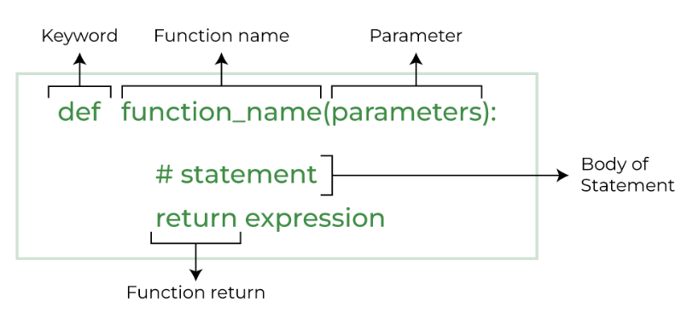

1. **Writing a program to create a normal function :**

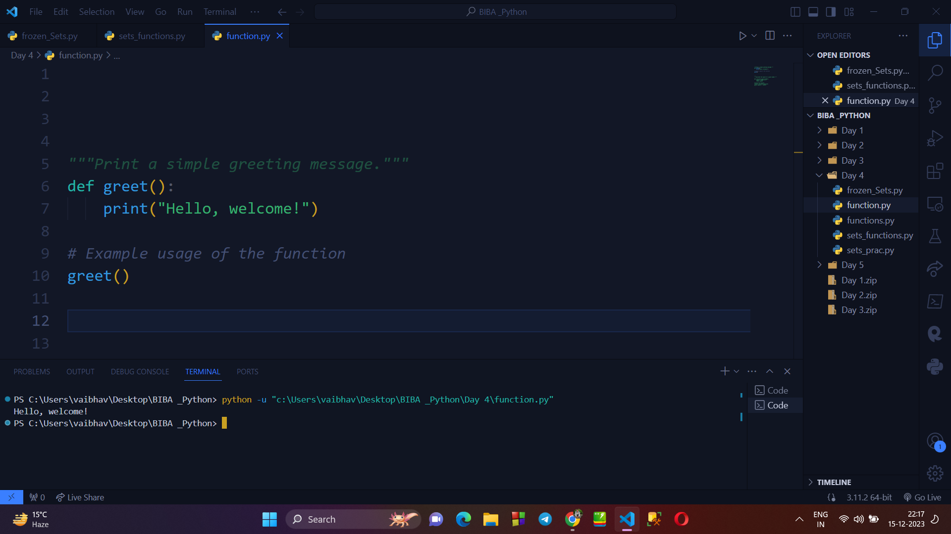

1. **Creating a function having PARAMETERS - (Even/Odd Function) :**

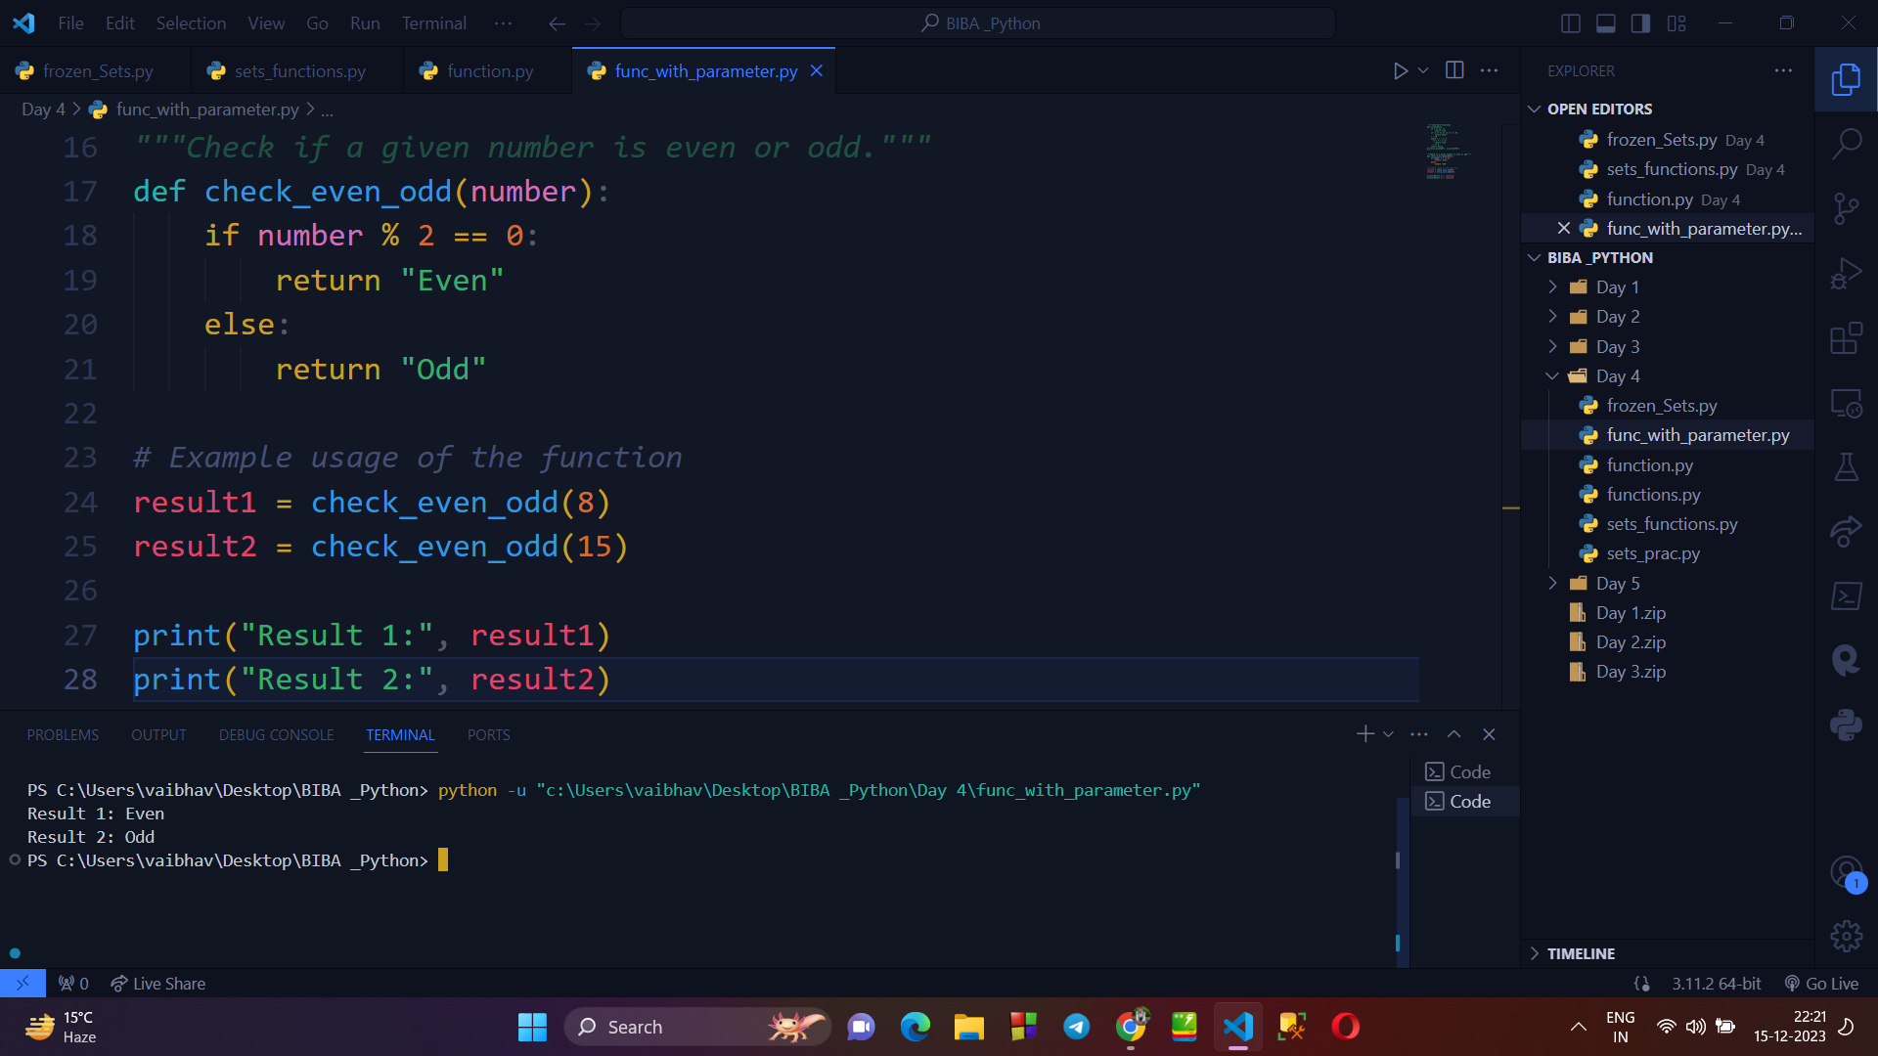

1. **Creating a function taking ARGUMENTS - (Rectangle Area Calculation) :**

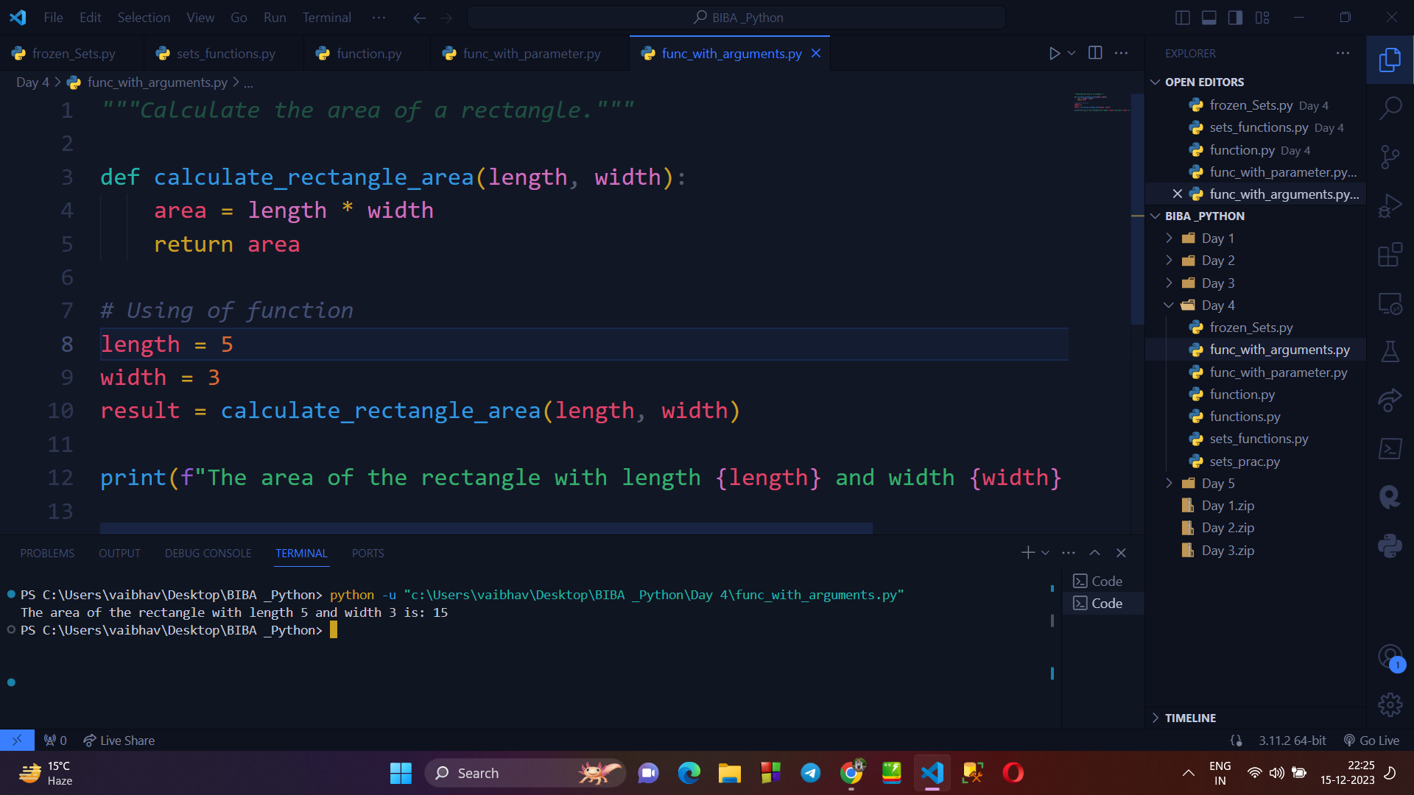

1. **Example of function with DEFAULT ARGUMENT :**

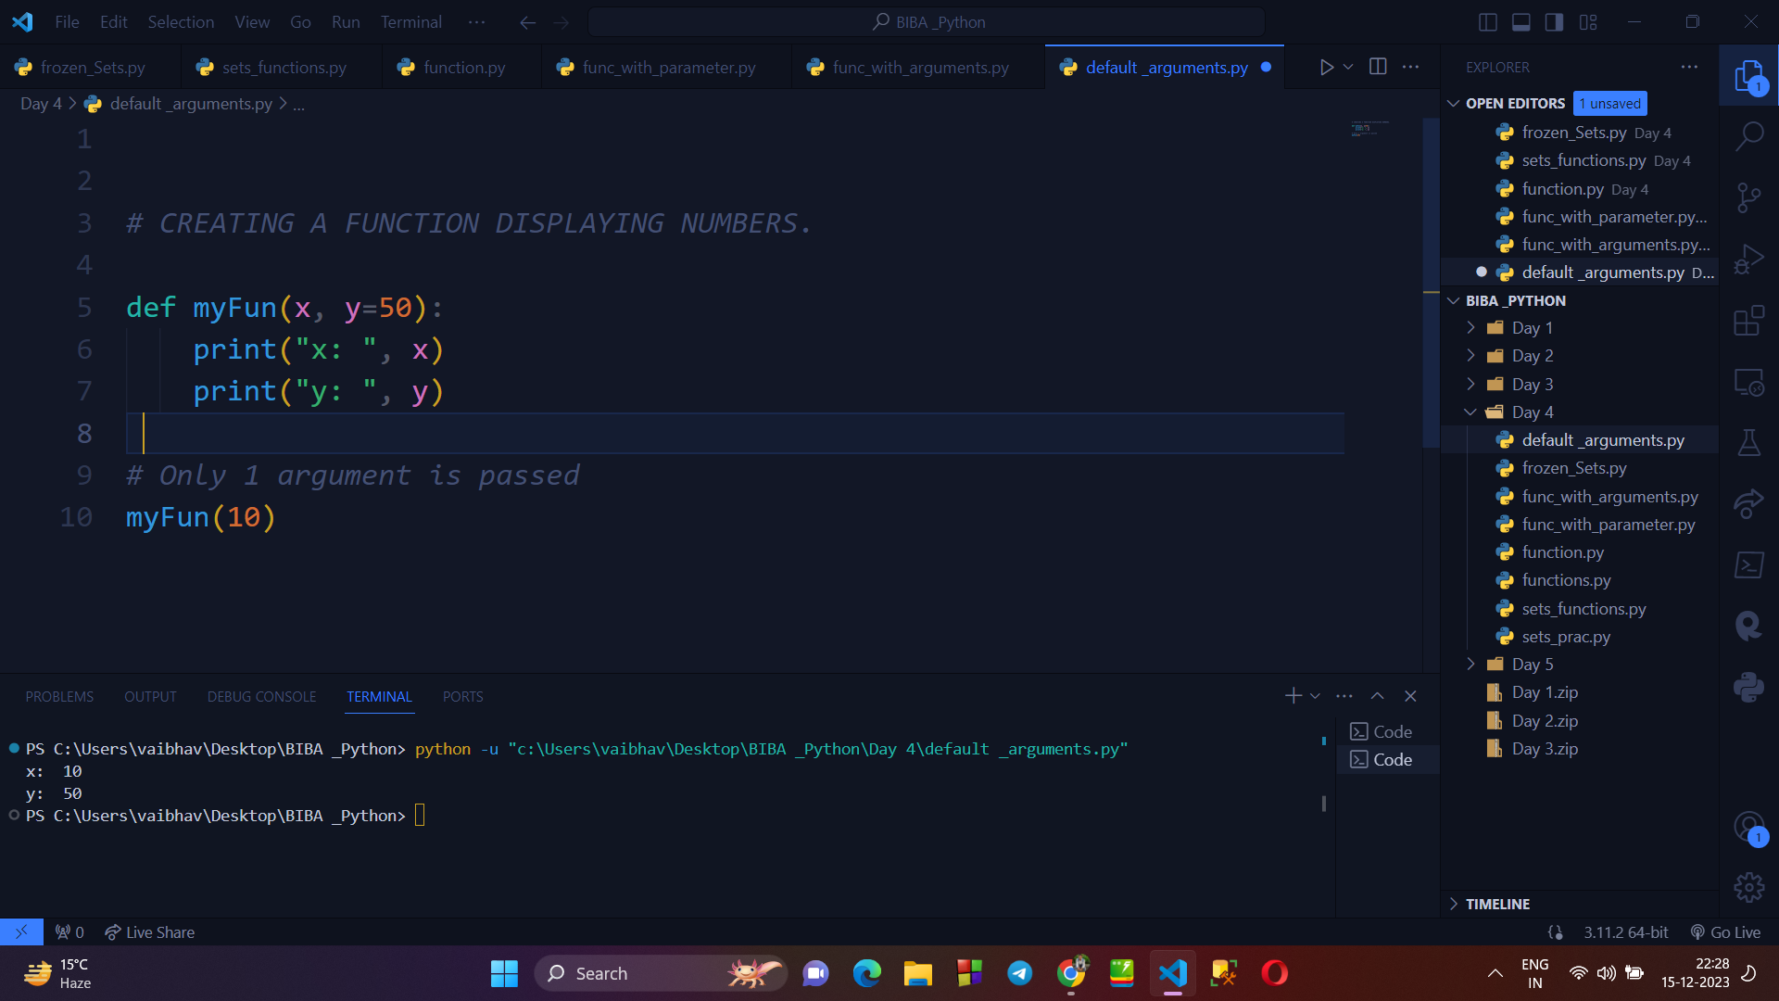

1. **Example of Keyword Arguments :**

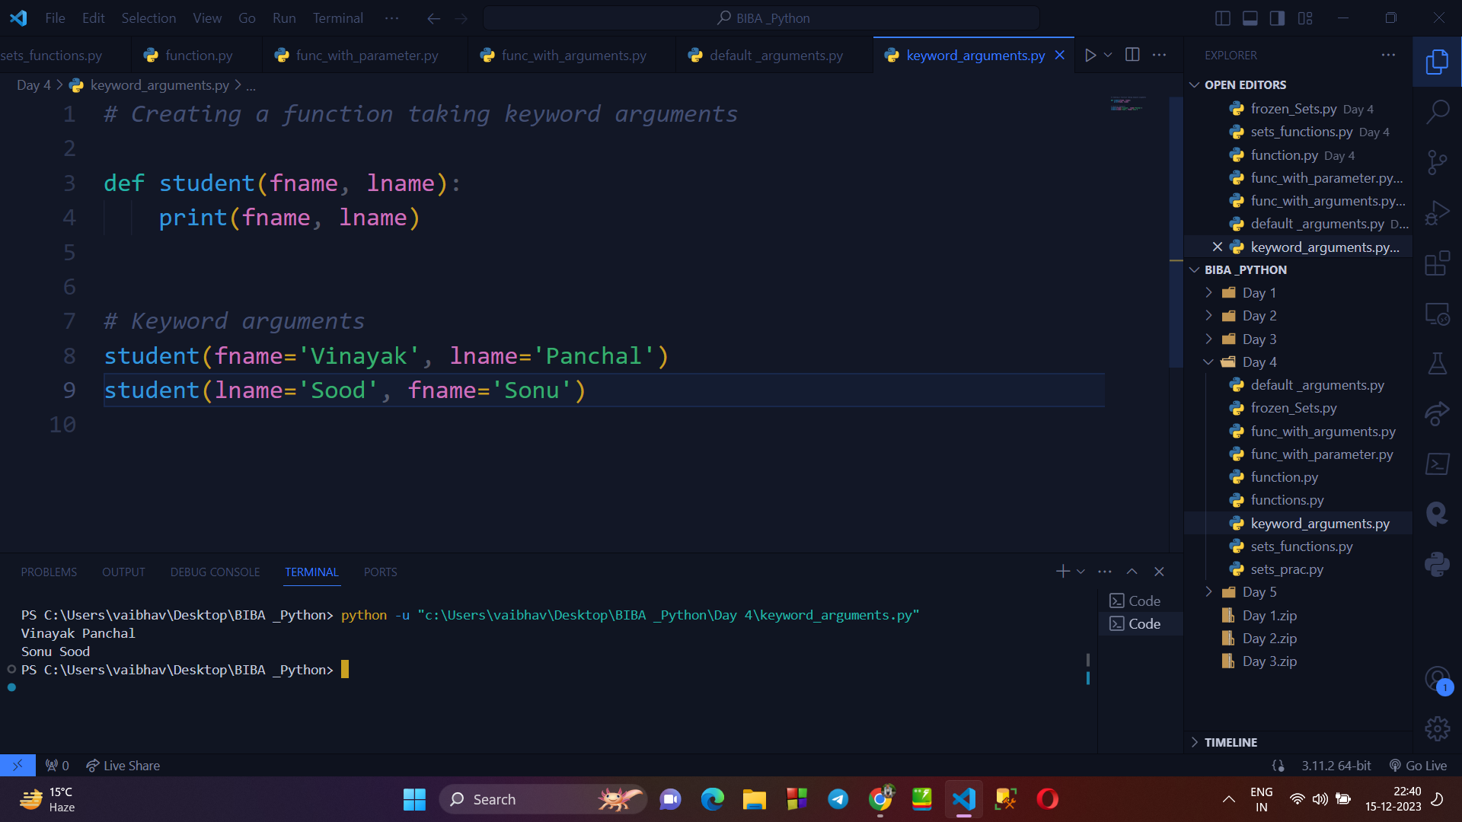

1. **Example of POSITIONAL ARGUMENT :**

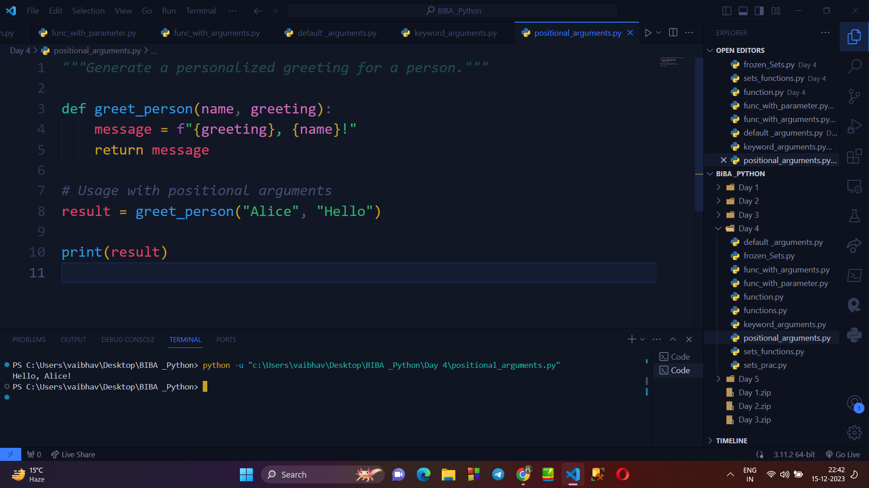

**→ DOCSTRING FUNCTION :**

* Docstring is the first string written after the function definition.
* It added with the output to make it more meaningful.

